Content Typle: Case Study

Title: Automated Tool (Data Quality Scanner®) Reduced Credit Reporting Discrepancies by 90 Percent

Tags: Credit Reporting, Credit Bureau Disputes, Regulatory & Compliance

Thumbnail Image: CaseStudy_Automated Tool Reduced Credit Reporting Discrepancies_600x33.png

As federal and state regulators increase pressure on data furnishers to ensure the completeness and accuracy of credit reporting data, organizations are spending increasing amounts of time and resources to stay in compliance. The Data Quality Scanner® solution (DQS) leads the industry in quickly and accurately assessing Metro 2® and other NSCRA file formats to ensure accuracy across multiple systems of record. Best of all, unlike other assessment tools, regulators recognize that the DQS provides an independent assessment of data file quality & that augments a furnisher’s quality review.
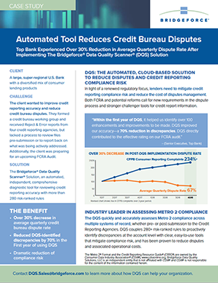
Read our case study showing how the DQS solution led to a 90 percent reduction in one client's credit reporting discrepancies. [LINK TO “CaseStudy_Automated Tool Reduced Credit Reporting Discrepancies.pdf”] Open PDF in a new window

Add thumbnail to the left named “CaseStudy_Automated Tool Reduced Credit Reporting Discrepancies_Cover.png” and link to the same link above.

